
Fecha recepción: 31/07/2025 Fecha revisión: 03/11/2025
Fecha de publicación: 30/01/2026

The Global Rise of Money Heist: From Antena 3 to Netflix
Joana Doñate-Ventura dovenjoana@gmail.com
How to cite this text: Joana Doñate-Ventura, Estéban Galán-Cubillo & Javier Marzal Felici (2026): From Antena 3 to Netflix: The rise of Money Heist as a global phenomenon, en Miguel Hernández Communication Journal, Vol. 17 (1), pp. 171 a 193. Universidad Miguel Hernández, UMH (Elche-Alicante). DOI: 10.21134/ns0mzq85
https://orcid.org/0000-0003-4992-6843
Universitat Politécnica de València
Estéban Galán-Cubillo |esteban.galan@uv
https://orcid.org/0000-0001-8718-0937
Universitat de València
Javier Marzal Felici| marzal@uji.es
https://orcid.org/0000-0002-2462-1122
Universitat Jaume I (España)

Sumario | Resumen
- Introduction  - The Restructuring of the Spanish Audiovisual System  - New Consumption Trends and Audience Segmentation  - Methodology  - Analysis and Results  - Background, Production, and Audience: The Leap from Antena 3 to Netflix.  - Content Strategy, Street Marketing and Impact on Social Media  - Comparison between Production and Distribution on Antena 3 and Netflix: Narrative and Stylistic Evolution  - Discussion and Conclusions  - References | The accelerated pace of production and consumption compels streaming platforms to acquire content and invest in reliable third-pay content in the countries where they operate. Upon entering the Spanish market, Netflix acquired the rights to Money Heist from Atresmedia and successfully relaunched the show to a global audience. An in-depth narrative and stylistic analysis, combined with a bibliographic review, was conducted, along with in-depth interviews with professionals from Netflix, the show, and the industry in order to assess the evolution of the series before, during, and after Netflix's acquisition. There is a significant improvement in stylistic and promotional quality, along with a narrative repetition throughout the seasons created by Netflix. The show's impact was amplified through content management and promotion both within and outside social media. Successful audiovisual products are often overexploited and expanded, leading to a long-term lack of creativity and audiovisual quality. Thanks to Netflix's acquisition, a local product was transformed into a global mass phenomenon.
Keywords
“Streaming”; “over-the-top services”; “Money Heist”; “advertising”; “Netflix”; “Antena 3”.

1. Introduction

1.1 The Restructuring of the Spanish Audiovisual System

The arrival of streaming platforms revolutionized the entire audiovisual industry. Anderson (2006, p. 23) spoke of "long tail" companies, referring to "Internet companies that eliminate the spatial and temporal boundaries of the economy and, therefore, increase participation and democratize access to culture." Any economic activity is subject to major changes that largely depend on consumption trends; however, these shifts are more pronounced in the entertainment sector due to its high social and technological component.
The rapid market penetration of these operators, with innovative business models, transformed the audience's audiovisual consumption habits. The emergence of Netflix and other streaming services marked the beginning of a new institutional logic in film production and distribution, creating a gap with traditional industry stakeholders. These platforms changed the relationship between consumers and distributors by replacing commitment with convenience. Compared to the traditional pay-TV services operating in Spain, Netflix's rapid expansion demonstrated an opportunity for an on-demand service at a reduced cost.
The consolidation of streaming platforms has led to a profound reconfiguration of the audiovisual ecosystem, affecting not only distribution but also production, financing, and content acquisition processes. Unlike the traditional television model based on linear programming and immediate audience measurement, platforms operate under an on-demand consumption logic that prioritizes catalog accumulation, algorithmic personalization, and prolonged content exploitation.
From an institutional logic perspective, organizations tend to become more similar over time, partly due to the mobility of human capital. Streaming services regularly hire traditional media executives, especially when the platforms are international. This approach allows them to gain deeper knowledge of the local market and the inner workings of potential competitors. This paradigm shift has fostered new industrial dynamics where series are no longer conceived as closed products tied to a programming grid, but rather as strategic assets for global circulation.
Contemporary seriality is characterized by greater narrative flexibility, a tendency toward universe expansion, and an increasing focus on brand building through content. In this new scenario, streaming platforms assume a central role as agents articulating the relationship between creation, distribution, and consumption. This vertical integration allows for greater control over creative processes and global exploitation, favoring the international circulation of series and the standardization of narrative and aesthetic patterns in a globally competitive context.

1.2 New Consumption Trends and Audience Segmentation

This "platformization" of culture follows economic criteria and leads cultural industries into a new era where algorithms determine content consumption and reinforce social profiles of culture consumers. New generations, digital natives of social media and the internet, are the ones setting the pace of production and consumption. The strategic key for streaming platforms is to acquire new audiences while retaining existing ones. This generates a need for periodic consumption, forcing a continuous release of new content, which in turn leads to the extension of product lifespans and fragmented release schedules. Diego Ávalos, Director of Original Content at Netflix Spain and Portugal, states that audience numbers are not the primary metric for Netflix; instead, the priority is ensuring users always have new and diverse content to prevent subscription cancellations. The accelerated pace of production by both platforms and traditional media, which have also had to increase productivity, can result in a lack of quality content and a diminished artistic sense of the work.

This variability, coupled with new accelerated viewing habits, brings about the era of "liquid audiovisuals," where content travels between screens and generates diverse viewing experiences. Series consumption has shifted toward a hybrid model where the viewing experience is complemented by active social media participation, expanding the narrative and symbolic reach of audiovisual products. As a reaction to the audiovisual bubble generated by platforms, the figure of the "author" has gained relevance. Platforms hire showrunners to ensure continued success with exclusive new products. The most emblematic Spanish case is Alex Pina, following Netflix's acquisition of Money Heist (La Casa de Papel) in 2017. After seeing limited success on Antena 3 (May 2017), the series was internationally catapulted by Netflix's acquisition in December 2017. Its success was driven by three factors: first, the platform's algorithmic system reaching a global audience; second, the high quality of Spanish fiction and its relatable themes across different territories; and finally, content promotion through social media and offline actions. This phenomenon is not unique to Money Heist.

Internationally, several platforms have revived or extended series originally made for television to give them global reach. Examples include The Handmaid’s Tale (2017), reformulated by Hulu as a long-running fiction with international projection, and Twin Peaks (1990), which was revived by Showtime decades later, adapting its narrative structure to a new on-demand ecosystem.

These cases highlight a common trend: platforms do not just produce original content; they act as industrial and cultural revitalizers capable of reformulating existing fictions for on-demand logic and global segmentation. While studies have analyzed the role of streaming in production and distribution (Neira, 2020; Castro & Cascajosa, 2020) and the impact of Netflix on digital promotion (Mayorga-Escalada, 2019; Doñate et al., 2024), there is a lack of research analyzing the narrative, stylistic, and communicative "before and after" of a series following its acquisition by a global platform. Addressing this gap, this study analyzes Money Heist as a quintessential example of a local television product transformed into a global phenomenon, combining narrative, stylistic, and marketing analysis

2. Methodology

At present, there has been an “acceleration in the production of the audiovisual industry that can only be described as a bubble” (Pérez et al., 2020, p. 400). This acceleration is shaped by the unequal conditions between streaming platforms and traditional media. At the same time, streaming platforms concentrate a large share of the audience due to their use of big data and the continuous release of new titles.
The general objective of this article is to examine the changes that occur in third-party audiovisual products when they are acquired by streaming platforms. To this end, the acquisition of La casa de papel by Netflix, originally produced for Antena 3, has been selected as the case study. This fiction was chosen for four main reasons: the transition from Antena 3 to Netflix, its remarkable national and international popularity, its representation of Spanish culture, and the extensive offline and online promotional strategy that accompanied it.
Accordingly, the specific objectives of this study are, first, to determine the differences in production and consumption between the versions of the same audiovisual fiction distributed by Netflix and Antena 3. Second, to analyse the technical, narrative and artistic parameters of La casa de papel in order to identify possible variations resulting from its acquisition and the continuation of its seasons. Finally, the study aims to address the different promotion and communication strategies that develop independently from the product itself and that consolidate both within and beyond social media.
In order to identify the differences between the production and distribution of La casa de papel on Antena 3 and its relaunch on Netflix, a comprehensive narrative and stylistic analysis was carried out on the five seasons of the series (2017–2021), as well as on its spin-off Berlín (2023), both produced by Vancouver Media. This case study was selected due to the notable decline in audience ratings the series experienced during its broadcast on Antena 3 and its subsequent international success following Netflix’s acquisition of the rights.
The comparative analysis between the seasons broadcast on Antena 3 and those produced by Netflix was conducted through an in-depth narrative and stylistic approach. In order to assess the differences between both formats, specific parameters were considered, including episode length, plot structure, character development and the technical resources used at each stage of production.
Particularly, the study examined how the cyclical narrative structure of the heists, together with the fast pace typical of Netflix’s binge-watching format, affected audience perception in comparison with the fragmented narrative structure shaped by the commercial breaks of Antena 3. From a stylistic perspective, significant changes were observed in the use of cinematography, lighting and art direction, which were assessed through a comparative visual analysis of key scenes from both stages.
In addition, the online and offline communication strategies employed by Netflix to promote La casa de papel were analysed in parallel, focusing on digital marketing campaigns, social media activity and brand collaborations. This analysis also included the review of product integration strategies and the expansion of the series’ universe through merchandising and interactive events.
The study was complemented by a literature review of key texts addressing the impact of streaming and social media on the audiovisual industry, highlighting works such as Streaming Wars by Elena Neira (2020) and the article “Netflix fictional feature film originals: an analysis of release strategies” by Roig et al. (2021). This theoretical framework provided contextual insight into the functioning and strategies of streaming platforms.
Furthermore, ten semi-structured interviews were conducted with key professionals from the industry, selected for their direct role in the production of the series and their relationship with Netflix. Interviewees included Diego Ávalos (Vice President of Original Content for Netflix Spain and Portugal), Víctor Martí (Head of Post-production at Netflix Spain), Eva Leira and Yolanda Serrano (casting directors of La casa de papel), among others. These interviews offered detailed insights into how professionals perceive the changes in the production and reception of the series following its incorporation into the streaming platform.
The selection of interviewees was based on criteria of professional relevance and diversity of roles within the industry, with the aim of obtaining a broad perspective on the changes introduced by Netflix after acquiring the series. Priority was given to professionals with direct responsibility in key areas such as production, casting, content development, communication and post-production. This diversity of fields made it possible to contrast creative, industrial and strategic perspectives, facilitating the analysis of the collected data and its connection with the literature review.
Finally, the research team conducted participant observation, which provided direct access to production teams. This participant observation took place in a professional context linked to the audiovisual industry, allowing direct insight into workflows, creative dynamics and decision-making processes. To document these observations, a field diary was kept in which the team recorded interactions and observations, providing qualitative data. Its incorporation into the methodological design helped strengthen and deepen the study by contributing information that would have been difficult to obtain through other research techniques.Current production acceleration in the industry can be described as a "bubble." This acceleration is conditioned by the unequal playing field between streaming platforms and traditional media. Platforms consolidate a large portion of the audience through big data and a continuous stream of new titles.
The general objective of this article is to understand what changes occur in third-party audiovisual products when they are acquired by streaming platforms. To this end, the study focuses on Netflix's acquisition of Money Heist (Antena 3). The series was chosen for four factors: the transition from Antena 3 to Netflix, its immense popularity, its representation of Spanish culture, and its extensive advertising strategy.

The specific objectives are:
1. To determine production and consumption changes between Netflix and Antena 3 for the same series.
2. To analyze technical, narrative, and artistic parameters of Money Heist to identify variations resulting from its acquisition and seasonal extension.
3. To address the promotion and communication strategies developed independently of the product, both online and offline.

To identify differences, an exhaustive narrative and stylistic analysis of the five seasons (2017) and its spin-off Berlin (2023) was conducted. Specific parameters included episode length, plot structure, character evolution, and technical resources. Narrative analysis explored how the cyclical nature of heists and Netflix’s binge-watching format impacted perception compared to Antena 3’s fragmented, ad-interrupted delivery. The study also analyzed Netflix’s online and offline communication strategies, including digital marketing, social media, and brand collaborations. This was complemented by a literature review and ten semi-structured interviews with key industry professionals, such as Diego Ávalos (Netflix VP of Original Content), post-production leads, and casting directors. Finally, participant observation provided direct access to production workflows and decision-making processes.

Table 1. Methodologies used in the research.
 | Narrative analysis: plot structure, character development, narrative tone and pacing, and recurring themes. |  | Stylistic analysis: focused on cinematography, production design, and technical resources.
  Narrative and
  stylistic analysis
  of La casa de papel
  (2017)
  and Berlín (2023)
Analysis of the online and offline communication strategy of La casa de papel (2017) and Berlín (2023) | Brand collaborations | Street Marketing | Social media | Interactive events
Literature review | Impact of streaming and social media on the audiovisual industry |  | Social media communication strategy
Ten semi-structured interviews conducted with industry professionals | Diego Ávalos, Vice President of Original Content at Netflix Spain and Portugal.  Víctor Martí, Head of Post-production at Netflix Spain.  Marc Randolph, co-founder of Netflix.  Iñaki Juaristi, Head of Production at Netflix Spain.  Alfredo Murillo, Head of Publishing & Social Media at Netflix Spain.  Eva Leira and Yolanda Serrano, casting directors of La casa de papel and Berlín.  Abdón Alcañíz, art director of La casa de papel.  Dario Madrona, executive producer at Grupo Z and co-creator of Élite.  Miguel Salvat, Head of Original Content at HBO Spain.  Elena Neira, expert in distribution and streaming platforms.
Source: Own elaboration

This methodological approach aims to identify and document the changes in production and consumption dynamics resulting from the transition of La casa de papel from a traditional television network to a global streaming platform, as well as the implications of these changes for the Spanish audiovisual industry.

3. Results
3.1. Background, production and audience: the transition from Antena 3 to Netflix

With Netflix’s entry into the Spanish audiovisual market, the platform sought to acquire national content in order to develop an identity connected to build a locally rooted identity. La casa de papel can be understood as “a continuation of third-party content” (Heredia, 2016, p. 280), referring to productions originally developed by other channels whose production, distribution and exhibition rights are later acquired by Netflix.

La casa de papel premiered on 2 May 2017 on Antena 3 and concluded that same year on 23 November. The first episodes of the first season attracted 4,090,000 viewers (a 25.1% audience share). However, the final episodes of the storyline failed to reach a 13% share. The decline in audience was gradual despite the sustained tension maintained throughout the narrative. This drop can be explained by the scheduling of the series in late prime time and by the large number of advertising breaks, as the episodes had a runtime of around 70 minutes. Netflix later acquired the first two seasons and produced three additional seasons, a documentary and a spin-off together with the original production company of the series, Vancouver Media.

Netflix’s production and consumption strategy achieved effects that contrasted sharply with those of Antena 3. Viewers were able to consume the content quickly and without interruptions. From a narrative perspective, uninterrupted viewing was also encouraged through the restructuring of plot developments and moments of tension, strategically placed at the beginning and end of episodes. The first and second parts of the series, originally produced by Atresmedia, were well received and helped stimulate interest in the third instalment. As a result, the third season reached 34 million viewers in the first days after its release. The season was divided into two release periods (September and December), a strategy aimed at extending and amplifying the media impact of the series finale.

The strong reception of the seasons on Netflix was also linked to changes in episode length and the fluid viewing experience between episodes. Unlike Antena 3, Netflix does not include advertising breaks, meaning the narrative is not fragmented or extended by interruptions. In addition, Netflix’s automatic playback of consecutive episodes encourages binge-watching. This viewing model enabled a fast and continuous consumption of the series, positioning it among the most-watched titles on the platform at the time of its release.

From the moment Netflix released the second season and announced the third, audience reaction became a key element in the platform’s strategic content reception. The third season was surrounded by criticism from some fans of the series, who rejected the idea of a continuation as well as the return of previously deceased characters. This situation generated an ongoing debate among experts, fans and critics about whether the series should continue, placing Netflix at the centre of public attention.

With the release of the new seasons produced by Netflix, a technical and stylistic improvement in the series became evident as a result of the increased production budget. However, while resources increased, the time available for certain processes—particularly pre-production—was reduced due to the global impact and growing relevance of the series.

Whereas the first two seasons of La casa de papel on Antena 3 were produced without audience reception influencing the storyline, the seasons produced by Netflix were strongly affected by it. Constant audience feedback through social media contributed to shaping elements of the narrative according to viewers’ preferences. This can be seen, for example, in the expanded narrative presence of Berlín within the plot or in the incorporation of feminist discourses through characters such as Nairobi, Lisboa and Tokio.

The storyline follows a largely linear structure but tends to adopt a cyclical pattern at the end of each season. This is also connected to the need to satisfy audiences through the reappearance of beloved characters such as Berlín or Tokio. Across the seasons, the narrative repeatedly relies on similar triggers, including character deaths, corrupt figures or failures in the Professor’s plan.

Both in the narrative and in the visual design, the series frequently references well-known films familiar to audiences, such as Ocean’s Eleven (2001), Reservoir Dogs (1992) and V for Vendetta (2005), in order to create a shared cultural imagery that viewers can easily recognise. This narrative parallelism is also reinforced by the increased budget of the production, which allowed for the inclusion of larger settings, more elaborate explosions and more spectacular visual elements. Examples include the significant transformation of the gang’s hideout, which becomes a large monastery, and the spectacular explosion accompanying Tokio’s death. These visual and narrative resources not only enhance the spectacle of the series but also demonstrate a deliberate adaptation of the story to the global consumption logic of streaming platforms, where emotional and visual intensification becomes a key element for audience retention.

Image 1. Frame from the first season of La casa de papel (Antena 3) and frame from the third season (Netflix).
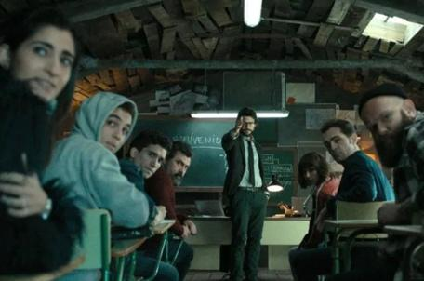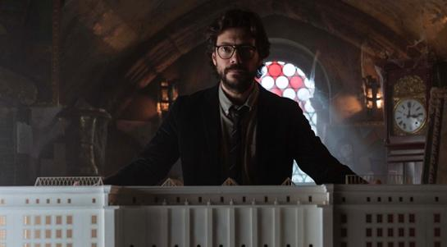
Source: Frames from the analysed fiction.

Image quality also shows a significant improvement, largely due to the richer use of lighting. In the early seasons, some spaces were already differentiated through warm and cool lighting, but this contrast becomes much more pronounced in the later seasons. Cooler tones and warmer interior spaces are used for the gang, while greenish tones are employed to portray the police (or characters located outside).

Image 2. Frames taken from the seasons of La casa de papel produced by Netflix.
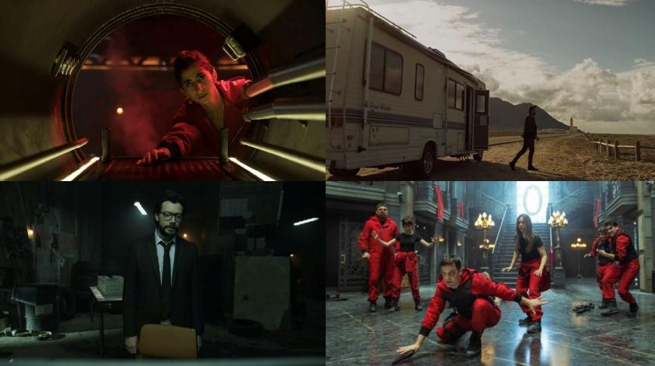

Source: Own elaboration

The color red holds major importance throughout the story. Beyond constantly dominating the visual imagery, it also serves as a symbol of the resistance and, therefore, of the robbers themselves. While the choice of red jumpsuits is motivated by the need to represent the working class, other symbols appear as well, such as the Dalí mask and the song Bella Ciao. Choosing Dalí aims to give the heist a distinctly national character by borrowing a symbol from modern Spanish art, whereas the use of the antifascist chant Bella Ciao seeks to create an anthem that connects the resistance with the working class.

The soundtrack, cinematography, and editing also gain greater weight in shaping the narrative. These elements are conceived from the script stage itself, moving away from the more problem-solving approach that characterized the first two seasons. The series also establishes parallels with other artistic works, such as the reference to The Passion by Michelangelo in Nairobi’s death. There are also echoes of other pieces of fiction, like the staging of Tokyo’s departure from the heist, which strongly resembles certain scenes seen in Game of Thrones (2011). In addition, the show creates parallels within its own narrative, particularly in the similarities between the deaths of Berlin and Tokyo.

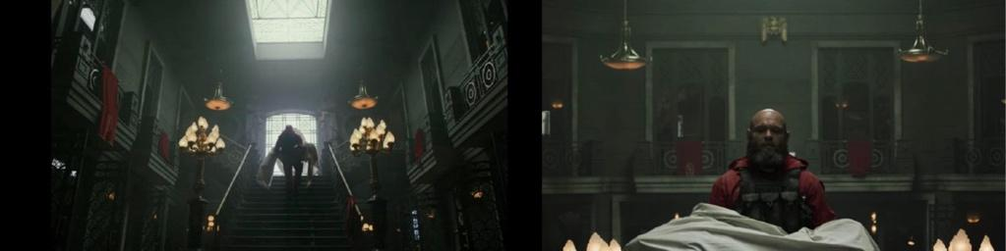
Image 3. Frame from the death of Nairobi.

Source: Own elaboration

Image 4. Comparison between Tokyo’s exit from the heist and the characters from the series Game of Thrones (2011).

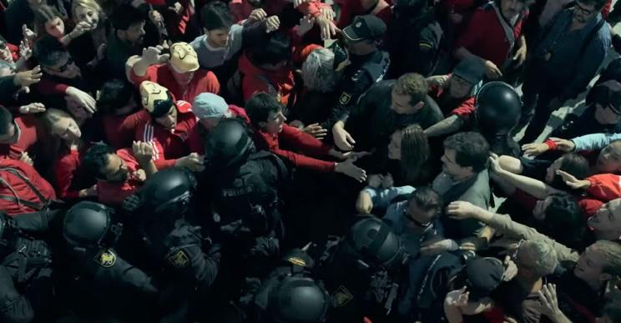

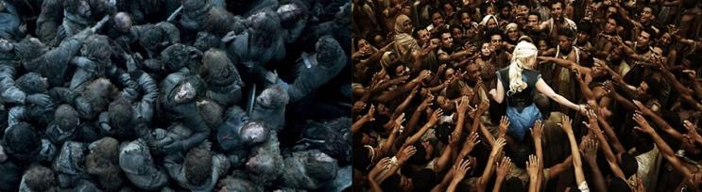

Source: Own elaboration

In addition, more musical scenes appear in the later seasons, such as the use of the songs Guajira Guantanamera by Compay Segundo, Ti Amo by Umberto Tozzi, and Centro di gravità permanente by Franco Battiato.

The acquisition and expansion of the series by Netflix led to stylistic, narrative, and technical improvements that become evident from the third season onwards. Together with the increased budget and the immediate global exposure of its productions, these factors allowed Spanish television fiction to achieve an unprecedented international reach.

Overall, the narrative changes, character construction, and visual design of La casa de papel reveal a gradual adaptation of the series to the consumption dynamics associated with streaming platforms. This evolution is not only the result of a larger budget, but also of a strategy aimed at maximizing spectacle, maintaining narrative continuity, and strengthening the viewer’s emotional engagement, thereby extending the series’ lifespan as a global franchise.

3.2. Content Strategy, Street Marketing and Social Media Impact

The promotional strategies developed by Netflix around La casa de papel follow a logic of integrated and transmedia communication, in which offline and online actions function as narrative extensions of the series’ fictional universe itself.

“In the process of brand management, content plays a leading role, being absolutely omnipresent” (Mayorga-Escalada, 2019, p. 239). “Netflix is an example of a brand that has found in the management of communication on social media its distinctive element” (Neira, 2020, p. 20). This brand being is reflected in the “personalization of the message and the use of first-person writing in posts” (Fernández-Gómez et al., 2022, p. 48).

Netflix has developed a branding strategy based on the cultural relevance of its original content, using its series as the main drivers of identity and differentiation from competitors. The acquisition of La casa de papel by Netflix was motivated by the platform’s need to project a closer and, ultimately, more Spanish image. The company has managed to “adapt its communication to local tastes in order to achieve better engagement with audiences” (Martín-Quevedo et al., 2021, p. 35).

Constant interaction with audiences in digital environments has become a central element in the brand positioning of streaming platforms, which seek to generate active communities around their content. “Netflix does not communicate in the same way or in the same proportions across all of its social networks” (Fernández-Torres and Villena-Alarcón, 2021, p. 36). In this context, “the use of memes has become a strategic communication tool, encouraging the viralization of content and emotional identification with audiences” (Arroyo-Almaraz and Díaz-Molina, 2021, p. 335).

A clear example of message diversity and meme culture can be found in the scene in which Denver calls his partner Tokyo a “Maserati.” Although the moment generated controversy on social media due to the objectification of the female character, it quickly turned into a viral meme through Netflix’s promotional message: “You are a Maserati. Don’t stay with someone who treats you like a 600.” This was followed by a response from Seat: “Unless ‘treating you like a 600’ means taking care of you for the next 50 years and sharing the rest of life’s adventures together.” This incidental line from the script illustrates how small narrative elements can be used to viralize content and extend its lifespan on social media.

The enormous success of the series also led to the production of a wide range of merchandising, further extending the life cycle of the show. Its profitability is therefore not limited to the time the product remains available on the platform, but also to its presence beyond it. Netflix Spain’s social media strategy has consistently kept the main characters of the series at the center of its promotional efforts. One of the most viral examples occurred during the 2019 Eurovision Song Contest, when Netflix brought together several contestants from previous years—such as Betty Missiego, Eleni Foureira and David Civera—in a promotional spot portraying them as the fictional band from the series. This promotional initiative, which takes advantage of a widely recognized national and international social event, is one of the strategic tools Netflix uses to promote its content and, above all, to create shared brand values with viewers.
With the premiere of the third season, several initiatives were launched with the aim of encouraging and motivating audiences to watch the new release: a countdown, questions directed at viewers about the plot, memes, and the placement of “wanted” posters featuring the faces of the main characters in the cities of Barcelona and Madrid. The first episodes were also premiered simultaneously outdoors at several strategic locations in different Spanish cities. These events were later shared by Netflix on its social media accounts as a way to highlight the success and fan enthusiasm surrounding the series.

On the other hand, the fourth season (3 April 2020), like many of the premieres released by Netflix during March, April and May of that year, was shaped by the global pandemic. Netflix announced the episode titles on 1 April 2020 through Instagram and X simultaneously, accompanied by Bella Ciao in the background. The announcement consisted of a short video of less than one minute in a square format, featuring red titles on a black background with the names of the eight episodes. Just one hour earlier on Instagram, the account had already announced the premieres scheduled for April through a post and several stories, with La casa de papel leading the list due to its imminent release two days later.

On 3 April, the day the fourth season premiered, the series quickly entered the Top 10 and within minutes had already reached the Top 3 in Spain. In fact, in Spain the platform experienced technical issues just one hour after the release (around 10 a.m.), reportedly collapsing due to the high demand. Two days after its premiere, the series had become the number-one most watched show in Spain, Sweden, Panama, Russia, Saudi Arabia, Slovenia, the United Arab Emirates, Switzerland, Slovakia, Ecuador, El Salvador, Venezuela, Bolivia, Lebanon, Belgium, Hungary, the Netherlands, Guatemala, Croatia, Austria, Poland, France, Serbia, Germany, Honduras, Turkey, Italy, Nicaragua, South Africa, Pakistan, Portugal, Paraguay, the Dominican Republic, Mexico, Argentina, Peru, Brazil, Chile, Nigeria, Vietnam, India and Malaysia, while also reaching the Top 3 in the United States.

A few days after the release, Netflix began posting on X and Instagram about individual episodes, while also uploading some of the most talked-about sequences and compilations of scenes or characters to its YouTube channel. At the same time, a documentary about the series was released, bringing together interviews with members of the technical team and the cast. The documentary Money Heist: The Phenomenon (2020) also became a successful global release and entered the Top 10 in several countries shortly after its launch.

The launch of the fourth season was therefore reinforced by a set of online strategies: the creation of exclusive content, interviews with the main actors, behind-the-scenes footage, the release of the documentary, and short clips from the series adapted for social media. This gradual strategy increasingly connected promotional material with the narrative itself, depending on viewers’ reactions and their engagement with the episodes.

In the case of the fifth and final season, the promotional strategy began with the release of the trailer and individual posters of the main characters, while also inviting fans to speculate about possible theories regarding the ending. At the same time, the cast received packages containing the Dalí mask, the iconic red jumpsuit and a personalized letter. After gathering fans’ responses to these theories, Netflix published several Instagram stories with the slogan “the answer is on the street,” which led to the appearance of outdoor advertising panels (mupis) in different cities displaying viewers’ questions in red lettering alongside the Dalí mask. In other locations, these panels were complemented with the corresponding answers, generating significant online and offline attention.

Image 5. Promotional images of La casa de papel on the Instagram account of Netflix Spain.
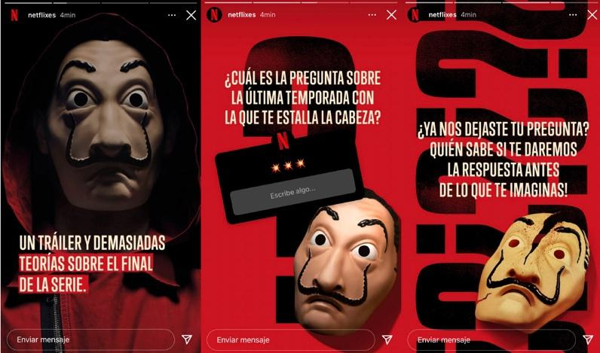

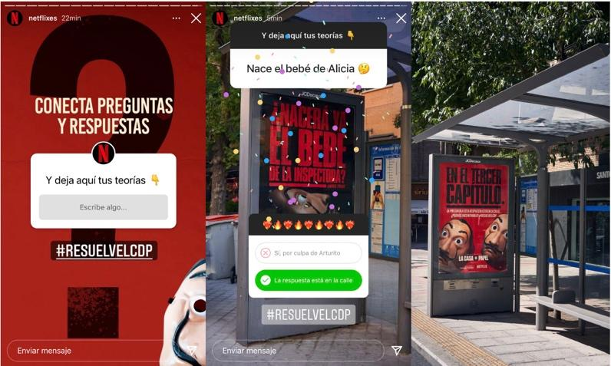

Source: Own elaboration

At the same time, the first 15 minutes of the episode were uploaded on the eve of the premiere. This action was announced ten minutes beforehand on Netflix’s Instagram account through a video featuring Berlin, which attracted more than 50,000 viewers watching live. In parallel, and following the split release of the fifth season, the documentary La casa de papel: From Tokyo to Berlin (2021) was produced, recounting the creative process behind the first five episodes that were released.

Regarding outdoor promotional actions, one notable example was the sculpture titled The Five Fallen, representing the characters Oslo, Moscow, Berlin and Nairobi in Buenos Aires, Colombia. In the sculpture, a large central block of stone was intentionally left uncarved, symbolizing the final character who would die in the last part of the series.

Another highly visible initiative was the construction of a La casa de papel falla in the central neighborhood of Ruzafa (Valencia) on the day of the plantà during the Fallas festival, coinciding with the release of the season. This installation was accompanied by several promotional actions: Instagram videos showing the construction process, paid advertising from Netflix Spain in Instagram stories promoting the content, and promotion on screens at nearby Fallas sites announcing the nit de la cremà of the La casa de papel monument. All these actions aimed to generate buzz around the monument while also building anticipation for what would happen when it was burned, framed by the question: “Will the resistance burn?”

In the days that followed, it became one of the most visited and photographed fallas, flooding social media and even generating some controversy within the Fallas community due to its promotional use. When the monument was finally burned, it left behind a metal structure in the ashes with the phrase “We will burn, but we will resist,” accompanied by the silhouette of the Dalí mask.

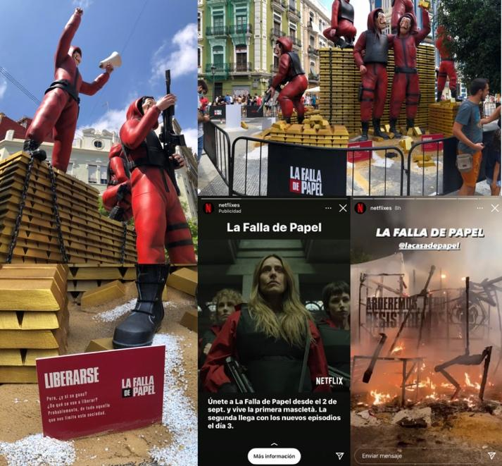
Image 6. Images of the La casa de papel falla and Netflix’s promotional campaign.

Source: Own elaboration

Parallel to this, brands took advantage of the media premiere, and many promoted their products by linking them to the show’s attributes during the opening week. This was the case, for example, with brands such as Pull and Bear, who released a clothing line under the La Casa de Papel license; McDonald’s, with the slogan “Ready for the biggest 'heist' [attraction] in history?”; and Valencia C.F., who presented their players dressed as the robbers. Other examples include Campofrío, who featured Helsinki withdrawing money from a bank in their highly anticipated 2021 Christmas commercial, or the version of Bella Ciao by singer Becky G, where she appeared in a red jumpsuit surrounded by gold ingots.

On December 3, 2021, the second part of the fifth season premiered, featuring the final five episodes of the series. A series of online and offline actions were carried out to build excitement for the finale of the acclaimed show, under the slogan of saying goodbye “to the resistance.”

The week leading up to the premiere was marked by media appearances from the main cast, most notably Pedro Alonso (Berlin) and Hovik Keuchkerian (Bogotá) on the show La Resistencia. During the interview, the actors explained one of the promotional stunts, which involved finding a real gold ingot hidden in Madrid by following clues left by the platform on social media. Another related action was the decoration of the interior and exterior of the Banco de España metro station in Madrid. The exit was filled with gold ingots, while the interior was papered in red and featured portraits of the robbers in large gold frames. Similarly, the metro station was vinyl-wrapped with images of ingots and series branding.

Simultaneously, a nationwide initiative was launched, which involved opening safes on a website created specifically for the occasion. On this site, users would watch a scene and, by entering the exact time code into the safe before anyone else, could win two tickets to the premiere of La Casa de Papel.

The premiere became a major event that was live-streamed through the same website created for the safe-opening challenge, and was later uploaded in its entirety to YouTube. Throughout the event, Netflix generated social media content, sharing the best highlights and raffling off a jumpsuit signed by the cast members among their followers.

Figure 7. Website created for the event's promotion.
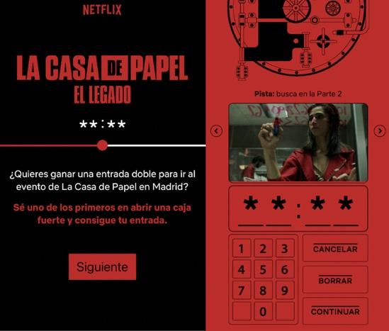

Source: Own elaboration

As a supplement to revenue generated from subscriptions, Netflix has consolidated the product placement formula, adapting it to the requirements of each plot and a global audience (Vilaplana et al., 2021, p. 19).

There is evidence of significant use of brand placement, particularly in the first two seasons developed by Atresmedia. A case in point is the use of the Estrella Galicia truck as the resolution to the organized gang's escape at the end of the second season; thus, the product is not merely "filler," but ultimately proves to be a key element in the heist.

These communication strategies highlight that the massive success of Money Heist [La casa de papel] is not based solely on its narrative premise, but on a transmedia conception of the product, where promotion, street marketing, and social media are integral parts of the story. In this way, Netflix transforms fiction into an expanded cultural experience capable of remaining active long after its premiere on the platform.

3.3. Comparison between production and distribution on Antena 3 and Netflix: narrative and stylistic evolution

The most significant change observed between Antena 3 and Netflix is the reduction in episode duration, which has allowed for a restructuring of narrative tension. This is particularly evident in the opening episode of the third season (Netflix), where action beats are meticulously placed to encourage binge-watching. Simultaneously, the cyclical evolution of the characters is maintained, as is the extension of the "life" of some of them, such as Berlin or Tokyo, who continue to participate in the plot despite their deaths.

Visually, there is a clear evolution in the use of color and lighting. For instance, while natural and less distinct tones predominated in the first seasons broadcast by Antena 3, following the acquisition by Netflix, there is a strong presence of the color red and its symbolic association with the resistance—a feature that is unmistakable in the scenes inside the heist.

The use of bluish lighting for scenes involving the police and green for those featuring the Professor underscores a higher level of visual sophistication. Color is employed not only to define spaces but also to mirror the personalities and emotions of the characters, as seen in the final episodes of the last season on Netflix. Regarding cinematography, Netflix stands out for its use of slow and fast motion during action sequences or moments of high plot tension, such as Tokyo’s death or the exit from the heist.

On the other hand, great importance is placed on music, which is used to create iconic scenes that later achieve significant impact on social media. This is the case with songs performed by Berlin (such as Ti Amo) in the seasons produced by Netflix, with scenes even being uploaded to social platforms in karaoke format.

Finally, the promotion of the series represents a major difference between Antena 3 and Netflix. While Antena 3 only promoted the show through on-channel advertising, Netflix utilizes every communication tool at its disposal, from its signature street marketing (such as bus shelter ads or the customization of Madrid metro entrances) to the use of memes from the show on social media.

Taken together, these differences demonstrate that the primary transformation is not limited to technical improvements, but rather represents a structural change in the conception of the audiovisual product. It has shifted from following a traditional television broadcast logic to being integrated into a digital ecosystem oriented toward continuity, viralization, and brand expansion.

4. Discussion and conclusions

The emergence of streaming platforms like Netflix has radically transformed the dynamics of production, distribution, and consumption of audiovisual content on a global scale. Money Heist (La casa de papel), a product initially conceived for Spanish television and audiences, has become an international phenomenon thanks to its relaunch on Netflix. This study analyzes how the series has undergone both a narrative and stylistic reinvention, accompanied by a highly effective global marketing strategy.

The results obtained from the narrative, stylistic, and strategic analysis confirm that Netflix's acquisition of Money Heist represented a turning point in its conception as an audiovisual product. As evidenced in the previous sections, the series progressively adopts a production logic oriented toward prolonged serialization, the spectacularization of the narrative, and transmedia exploitation—elements that reinforce its positioning as a global franchise within the streaming platform ecosystem. Likewise, changes in production and content reception are examined within the context of streaming platforms and their capacity to reconfigure audiovisual markets. It is established that:

1. A significant transformation has occurred in the way audiovisual content is produced and promoted, moving closer to cinematic standards in terms of both visual quality and the creation of spectacles. This strategy seeks not only to increase the perceived value of national products but also to ensure their viability in the global market, resulting in the successful internationalization of productions previously considered local in scope, such as Money Heist.

2. The franchise has continued to expand from its purchase in 2017 to the present. In the current context of audiovisual entertainment, it is evident that commercial logic prevails over the need to end profitable franchises. When Money Heist concluded in 2021, the Berlin spin-off and the Korean remake were immediately announced. This strategic expansion reaffirms the trend of maximizing the longevity of successful products through new versions and international adaptations.

3. The global impact of Money Heist is indisputable, consolidating itself in the top 5 premieres in most countries where Netflix operates. This success can be largely attributed to the platform's ability to offer a highly adaptable and universally attractive cultural product, adjusting to the tastes and trends of diverse audiences.

4. The advertising strategies for both Money Heist and its spin-off Berlin are based on the creation of exclusive content inside and outside social media, with a clear focus on audience interaction and engagement. These campaigns not only reinforce the series' presence in the collective imagination but also foster the creation of fan communities that actively participate in its promotion through content viralization.

5. Consequently, Netflix has managed to dominate the social media sphere by creating easily viralizable content that generates instant identification among users. This approach allows the platform to remain in the public conversation and ensures the relevance of its productions beyond the screen, thus reinforcing its position as a leader in the distribution and promotion of audiovisual content.

Money Heist represents not only a milestone in the history of Spanish television but also a paradigmatic case of the power of streaming platforms to turn local products into world-class cultural phenomena. Through a combination of narrative, stylistic, and advertising strategies, Netflix has succeeded in positioning the series and its spin-off Berlin as benchmarks for the new model of audiovisual production and consumption. This evolution evidences not only the impact of platforms on content globalization but also their capacity to extend the useful life of successful franchises by creating new narrative and commercial opportunities. The high volume of information circulating across multiple channels encourages individuals to develop filtering mechanisms based on the sources they engage with. These mechanisms range from the selective use of specific online media outlets to the reliance on social media platforms such as Facebook, Instagram, or Twitter as key gateways for accessing and processing information.

5. References

Anderson, C. (2006). La economía Long Tail. De los mercados de masas al triunfo de lo minoritario. Urano.
Arroyo-Almaraz, I. y Díaz-Molina, R. (2021). El fenómeno del meme en la estrategia creativa de Netflix España en Twitter. Icono 14, 19(2), 312-338. https://doi.org/10.7195/ri14.v19i2.1660
Benioff, D. y Weiss, D. B. (2011). Juego de tronos [Serie]. HBO.
Castro, D., y Cascajosa, C. (2020). From Netflix to Movistar+: How Subscription Video-on-Demand Services Have Transformed Spanish TV Production. JCMS: Journal of Cinema and Media Studies, 59, 154-160. https://doi.org/10.1353/cj.2020.0019
Darabont, F. (2010). The Walking Dead [Serie]. AMC.
Doñate, J. (2022). Producción original en Netflix España: La casa de papel y Paquita Salas (Tesis doctoral). Universitat Jaume I, España. http://hdl.handle.net/10803/674325
Doñate, J., Galán, E. y Marzal, J. (2024). El meme como herramienta de comunicación de éxito en Netflix España: El caso de la quinta temporada de La casa de papel. Hipertext.net, (28), 105-128. https://doi.org/10.31009/hipertext.net.2024.i28.09
Duffer, M. y Duffer, R. (2016). Stranger Things [Serie]. Netflix.
Eguizábal, R. (1998). Historia de la publicidad. Celeste.
Fernández-Gómez, E., Martin-Quevedo, J., y Feijoo Fernández, B. (2022). Netflix’s communication strategy on Twitter and Instagram during the unlock in Spain: humour, proximity and information. Observatorio (OBS*), 16(3). https://doi.org/10.15847/obsOBS16320222054
Fernández-Torres, M. J. y Villena-Alarcón, E. (2021): Posicionamiento en los entornos digitales: el caso de Netflix y su interacción con los públicos. Fonseca, Journal of Communication, (22). https://doi.org/10.14201/fjc-v22-22693
Flayelle, M., Maurage, P., Di Lorenzo, K. R., Vöguele, C., Gainsbury, S.M. y Billieux, J. (2020). Binge-watching: What do we know so far? A first systematic review of the evidence. Current Addiction Reports, 7(1), 44-60. https://doi.org/10.1007/s40429-020-00299-8
González-Neira, A., Quintas-Froufe, N., y Gallardo-Camacho, J. (2020). La medición de la audiencia televisiva: desafíos ante las nuevas plataformas de vídeo. Comunicación y Sociedad, e7284. https://doi.org/10.32870/cys.v2020.7284
Neira, E. (2020). Streaming Wars. La nueva televisión. Libros Cúpula.
Hadida A. L., Lampel, J., Walls, W. D., y Joshi, A. (2021). Hollywood studio filmmaking in the age of Netflix: a tale of two institutional logics. Journal of Cultural Economics, 45(2), 213-238. https://bit.ly/3KZmPOS
Heredia-Ruiz, V. (2017). Revolución Netflix: desafíos para la industria audiovisual. Chasqui. Revista Latinoamericana de Comunicación, 135, agosto-noviembre 2017 (Sección Ensayo, pp. 275-296). Disponible en: https://tinyurl.com/2fb92vp8
Lynch, D. (1990). Twin Peaks [Serie]. ABC.
Martín-Quevedo, J., Fernández-Gómez, E., y Segado-Boj, F. (2021). La estrategia promocional de Netflix y HBO en Instagram en un escenario de competencia. Análisis de sus perfiles en España y en EE.UU. Obra Digital, (20) https://doi.org/10.25029/od.2021.290.20
Mayorga-Escalada, S. (2019): Netflix, estrategia y gestión de marca en torno a la relevancia de los contenidos. adComunica,18, 219-244. https://raco.cat/index.php/adComunica/article/view/365734
Miller, B. (2017). The Handmaid’s Tale [Serie]. Hulu.
Pereira-Villazon, T. y Portilla, I. (2020): La gestión de la marca del programa frente a la marca corporativa en redes sociales. Caso: La casa de papel. Estudios sobre el mensaje periodístico, 26(4), 1543-1553. https://doi.org/10.5209/esmp.67807
Pérez-Rufí, J., Gómez-Pérez, F. y Castro-Higueras, A. (2020). Panorama de las plataformas de televisión OTT: agentes del mercado audiovisual y estrategias comerciales”. Comunicación y diversidad. Selección de comunicaciones del VII Congreso Internacional de la Asociación Española de Investigación de la Comunicación (AE-IC). Valencia, España, 28-30 de octubre, pp. 391-403. EPI SL. https://doi.org/10.3145/AE-IC-epi.2020.e25
Pina, A. (2017). La casa de papel [Serie]. Netflix.
Pina, A. (2023). Berlín [Serie]. Netflix.
Puro Marketing (2020). La brutal cantidad de dinero que Netflix se estaría gastando en marketing. https://tinyurl.com/3wvn7y4c
Roig, A., Clares-Gavilán, J. y Sánchez- Navarro, J. (2021). Netflix fictional feature film originals: an analysis of release strategies. Communication & Society, 34(2),125-139. https://doi.org/10.15581/003.34.2.125-139
Vilaplana-Aparicio, M. J., Boix-Romero, J., y Ortiz, M. J. (2021). Análisis del emplazamiento de producto en tres series originales de Netflix. Comunicación y Sociedad, 1-25. https://doi.org/10.32870/cys.v2021.8001
Zeko, A., Jakopec, A., y Lesinger, G. (2019): Television vs socialmedia-anewconcept for viewing series. Collegium Antropologicum, 43(4), 281-288. https://hrcak.srce.hr/file/3477


Licencia Creative Commons
Miguel Hernández Communication Journal mhjournal.org

