
Submitted: 19/09/2025 Approved: 8/12/202
Published: 30/01/2026

Adaptation of graphic novels to televisión fiction. The case of La Fortuna (Movistar+, 2021)

Javier Mateos-Pérez jmateosperez@ucm.es
How to cite this text: Javier Mateos-Pérez (2026): La adaptación de la novela gráfica a la ficción televisiva. El caso de La Fortuna (Movistar+, 2021), en Miguel Hernández Communication Journal, Vol. 17 (1), pp. 41 a 58. Universidad Miguel Hernández, UMH (Elche-Alicante). DOI: 10.21134/gmsfk228

https://orcid.org/0000-0003-2056-8704
Universidad Complutense de Madrid (España)

Sumary | Abstract
- Introduction  - Analysis proposal  - Background  - Methodology  - Results  - Conclusions  - Bibliographical references | The number of television dramas has increased exponentially in the new century with the advent of streaming platforms. This context of intensive creation has demanded narrative flows from all cultural industries and adaptations from different media. It is therefore understandable that adaptation practices have become central to the creation of television fiction. The goal of this work is to analyse La Fortuna (Movistar+, 2021), which adapts the graphic novel El tesoro del cisne negro (Roca, 2018) for television, in order to understand the reworking and transformation from print to audiovisual. To this end, a qualitative methodology based on comparative narrative analysis is proposed. It is evident that the television adaptation presents discursive differences with structural, thematic, and dialogic variations. It is concluded that, rather than adaptation, it is more appropriate to speak of the creation of a new work, autonomous from the original text, composed of additions, extensions, and transformations.
Keywords
“Adaptation”; “Television fiction”; “Graphic novel”; “Spanish television”; “Alejandro Amenábar”; “Paco Roca”

Introduction

The number of television fiction works has increased exponentially in the digital era. This progression has intensified during the second decade of the twenty‑first century with the advent of streaming platforms (Soto, 2023). The rise in operators has multiplied production volume and, consequently, proposals within the most frequent genres — drama, comedy, or thriller — as well as others that are more specific — fantasy, horror, science fiction — have increased as they seek to attract mass audiences.
This context of intensive creation has demanded a continuous multitude of ideas, allowing for the observation of a constant circulation of narrative flows originating from cultural industries, national contexts, and sources of all kinds. Thus, the narrative extension of stories has been stimulated, beyond the creation of new seasons.
For example, new versions of works are produced, repeating, with a certain degree of fidelity, the original stories and maintaining the same characters (remake or reedition); pre‑existing series are reinvented while preserving their most relevant narrative elements (reboot or restart); new fictions derived from others are proposed, based on a key component such as characters, settings, the universe of the original work, and so forth (spin‑off or offshoot). Fictions are also created based on the same universe but set in a later time period (sequel) or an earlier one (prequel); or narratives from works originating in traditional media are adapted for television, such as theatre, cinema, literature, and even others that are less conventional, such as comics, true‑crime news or video games.
All these commercial proposals demonstrate that adaptation practices have become central to current processes of creating television fiction.
This trend of adapting stories from other media for television is functional for production, since it facilitates the creators’ work by providing them with plots, contexts, characters, storylines, and so forth, that are already constructed. In addition, these stories benefit from the existing audiences of the original work, from their presence in public debate, from fan contributions, or may even profit from the cultural reputation of the source text. In sum, a work that achieves relevance within its domain facilitates its transposition to the television medium (Canovaca, 2017, p. 71).
Adaptation into television fiction grants, a priori, a supposedly greater degree of effectiveness, at least from a commercial standpoint (Verevis, 2006, p. 3; Pérez, 2010, p. 22), because the work possesses recognition and has already been validated by a given audience. Indeed, it is frequent that, upon the release of the television series, both sales and consumption of the cultural product from which the adapted work originates (comics, video games, films) also increase.
In recent times, the television adaptation of comics has become a frequent and lucrative practice. The paradigm is the series that adapt comics starring superheroes, particularly those from publishers such as DC or Marvel. However, the tendency to adapt so‑called graphic novels has recently increased. These have become an emerging narrative source for television fiction because both media share essential features that facilitate adaptation, such as serialised structure or the ability to compose stories of varying narrative extension.
It is often assumed that if a story can be told in comic form, it can also be told in audiovisual format, in the sense that the work already possesses a predetermined visual framework, thus assuming shared aesthetic parameters and common structures. Likewise, both the graphic novel and the traditional comic offer stories in instalments and allow for the evolution of an iterative narrative structure that coincides with that of the series. The fact that the stories of graphic novels often operate within a realistic, dramatic register centred on archetypal characters grants them maximum potential for adaptation to the television format.
The most significant case is The Walking Dead (Darabont et al., 2010–2022), a massively popular cult television series about zombies, based on the comics by Robert Kirkman and Tony Moore. This universe comprises eleven seasons and half a dozen derivative titles. It constitutes a fruitful formula, as it attracts a considerable share of the audience, generates substantial economic profits through commercial exploitation, and simultaneously functions as an inexhaustible reservoir of plots, storylines, and characters.
This adaptive trend has also reached Spain. Comics, in their various forms (single‑issue booklets, bande dessinée albums, or graphic novels), are beginning to be used as source texts for composing television narratives. Either following the path of Spanish‑style superhero comics — El vecino (Netflix, 2019–2021); ¡García! (HBO, 2022) — or through an authorial graphic‑novel approach, as in the case of La Fortuna (Movistar+, 2021).

Proposal for analysis
La Fortuna, produced by Movistar+ and the pay‑TV channel AMC, was presented in the Official Section of the 65th San Sebastián International Film Festival, and its television premiere took place on the Spanish platform on 30 September 2021. It is the first series directed by Alejandro Amenábar, who, together with Alejandro Hernández, adapts the graphic novel El tesoro del Cisne Negro, the original work and script by illustrator Paco Roca and diplomat and writer Guillermo Corral. The creation of this series, therefore, stems from a synergy of professionals who have built established careers within cultural fields outside the television sector.
La Fortuna is an example of interest in the adaptive process due to the convergence of creators it brings together. Precisely, Movistar+ based its promotional campaign on emphasising authorship: “La Fortuna. Una serie de Alejandro Amenábar”, which appeared on the series’ official poster.

Figure 1. Promotional poster for the premiere of La Fortuna

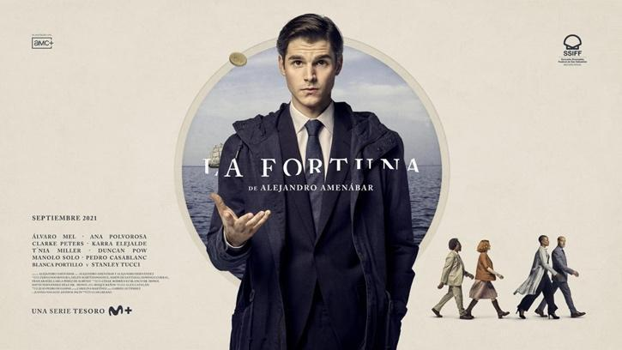
Source: Movistar +, AMC y SSIFF
It is therefore understood that Amenábar possesses a series of stylistic traits of his own in the creation of his works and that the themes he addresses propose a particular and singular way of seeing and telling the world.
Following this reasoning, the seven films in which he appears as director and screenwriter may be conceptually divided into a first stage —Tesis (1996), Abre los ojos (1997), and Los otros (2001)— with a marked preference for mystery and suspense; and a second stage, which shares humanist themes and causes.
Thus, he presents melodramas based on real events that depict rational characters confronting injustices of power, through conflicts such as the right to a dignified death (Mar adentro, 2004); tolerance in the face of religious dogmatists (Ágora, 2009); and opposition to ideological opponents of freedom (Mientras dure la guerra, 2019). The plots developed in his most recent works reveal Amenábar’s interest in positive social themes that encourage tolerance, good sense, and community, and which criticise sectarianism, imposition, and intransigence.
He is an author recognised internationally by critics, the industry, and the public, and he holds distinguished awards. Amenábar is considered one of the most significant Spanish audiovisual authors because he has managed to integrate commercial and auteur cinema (Rivero, 2019), and to blend Hollywood tradition with the Hispanic‑European one (Maule, 2007).
On the other hand, the source text is conceived by Paco Roca, who is regarded as the current leading figure of Spanish comics and the most (re)known graphic novelist today (Pereira, 2018), and whose works sell in the thousands (Cavanilles, 2018; Ceberio, 2024).
Roca brings to the graphic novel stories extracted from real events that he has experienced first‑hand or that have been conveyed to him by a source. This is how his major works arise: Arrugas (2007), El invierno del dibujante (2010), Los surcos del azar (2013), La casa (2015), El abismo del olvido (2023) or El tesoro del Cisne Negro (2018). The latter was a bestseller: in the first two weeks it sold 30,000 copies (Cavanilles, 2018). However, the idea came from Guillermo Corral. The diplomat knew the story because he participated in the case. Roca was in Washington, presenting the film Arrugas (Ignacio Ferreras, 2011), when Corral, then cultural attaché in D.C., proposed that he tell the story (Cavanilles, 2018).
La Fortuna is a fiction series with the refinement of major productions: high production values, a large and international ensemble cast, filming in different countries, and so forth. Furthermore, the narrative has had a direct cultural and social impact, since both the historical documentation and the treasure are public and may be visited in the permanent exhibition Nuestra Señora de las Mercedes (Figure 2) at the National Museum of Underwater Archaeology (ARQVA) in Cartagena. And, because of the case, UNESCO included its catalogue entry in the Register of Best Practices of Underwater Heritage (2015). The court ruling in favour of the Spanish State has set a precedent that establishes jurisprudence and foundations for marine archaeology.
Finally, the narrative also offers the appeal of proposing an unprecedented perspective that delves into the inner workings of Spanish politics and international relations.

Figures 2, 3, and 4: Exhibition of the collection: Nuestra Señora de las Mercedes
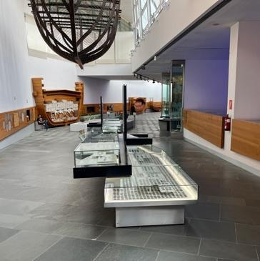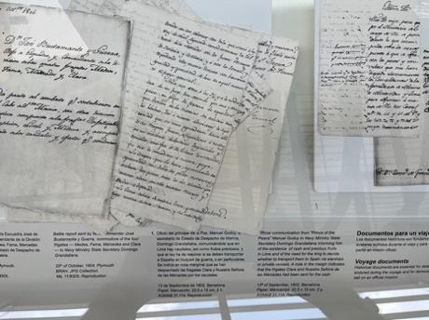
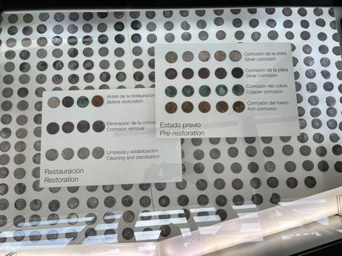
Source: National Museum of Underwater Archaeology

And, in relation to the academic sphere and the industry, studying the relationships between comics and the audiovisual sector is useful because the existing academic research is scarce, despite the proliferation of the adaptive phenomenon between these media on a global scale, and what does exist encompasses foreign works and applies methodologies that refer to the cinematographic medium (Gutiérrez, 2010; López, 2012; Brembilla and Guglielmo, 2018; López, 2020; Aertsen, 2021), sidelining television studies and ignoring its serial nature, which should determine any methodology that aspires to study it (Garín, 2017, p. 27).

Background

The cultural valorisation of comics has increased thanks to the graphic novel. The nominal evolution referring to the medium — from comic to graphic novel — has been decisive and positive, because the graphic novel “responds to an aspiration aimed at consolidating the comic within an adult cultural context, stripping it of the stigmatisation that has accompanied it since its origin, and evoking a form of high art, like the novel” (Flantrmsky‑Cárdenas, 2022, p. 7).
The graphic novel, as previously occurred with television fiction (Cascajosa, 2016), has achieved recognition as a legitimised cultural object. In fact, it fulfils the three forms of capital — cultural, economic, social — within Bourdieu’s distinction of taste (2015); it is sanctioned as artistic; it is classified as the ninth art; and it is capitalised for bourgeois consumption.
The cultural revaluation of the graphic medium has also involved a shift in focus in its content (Pereira, 2018). The graphic novel is distinguished by proposing narratives that present personal, autobiographical, or memory‑based themes, projected onto the page through a pronounced authorial perspective (El Refaie, 2015; Earle, 2017; Pereira, 2018).
The graphic novel differs from comics because it has a limited length, described as “one shot”, in contrast with the serialisation of comics (Baetens & Frey, 2015). Likewise, this format favours a reading not necessarily linear, which requires pause, reflection, and rereading, demanding a higher degree of cognitive commitment and promoting both understanding and enjoyment on the part of the reader‑viewer (Faust & Glenzer, in Pereira, 2018).
The development of the adaptation of the graphic novel to television fiction indicates the medium’s flexibility, as well as its particular connection and suitability for the screen, as it alludes to the multiple nature of the audiovisual narrative and its capacity to absorb all kinds of structures, languages, and codes to produce a unified text (Peña, 2007).
Graphic novels and television series are two closely related formats due to their serial nature and because they operate as devices that unfold narratively by activating and triggering a succession of images. Both media are structured through episodic and serial plots (Raya, 2017). Although both combine verbal and visual codes, they differ in that the graphic novel’s image is static, whereas on television it moves, and pagination is to comics what time is to television fiction (McCloud, 1994).
Here, the term adaptation refers to the result of transferring a work to the audiovisual medium from any other medium. Adaptation is often surrounded by a certain halo of critical rejection, as it is understood that the product is repeated and denotes little innovation on the part of its creators. However, this tendency is changing.
In contemporary cultural contexts, the myth of the singular value of novelty has been replaced by a new paradigm, since within the fictions of repetition, series possess originality precisely due to their potential to unfold and connect with other narratives and storyworlds (Balló & Pérez, 2005). This position — which maintains that adaptation does not possess less significance than original literary or cinematic works — was already suggested at the beginning of the digital era (Serceau, 1999).
Regarding fidelity, it can be concluded that adaptation is not based on mimicry, but on the transformation into a new reality (Moran, 2007). Pérez Bowie (2010) proposes the concept of rewriting — telling the story again — and argues that adaptation must involve a reformulation of the text and present a new perspective. This rewriting is a transposition (2010, p. 39), or, in other words, a form of hypertextuality that consists of transferring a text into another that repeats it while simultaneously transforming it (2010).
Ultimately, there is consensus that adaptation implies a transformation of semantic content, temporal categories, enunciative instances, stylistic processes, communicative situations, and modes of consumption between users of both messages (López, 2012).
After half a century of development, adaptation studies have evolved. On one hand, there has been a shift from a literary centre towards musical, performative, audiovisual, graphic, and digital narratives.
On the other hand, the intermedial and transtextual practices offered by creative rewritings, as well as the transfictional expansions of the text — sequels, prequels, extensions, serialisation and other transmedia phenomena — are considered (Gil González & Pardo, 2018). Under this logic, authors such as Scolari (2013) and Jenkins (2003) argue that expansion is the representative element of the transmedia narrative because the source text is told through two or more media. Pérez Bowie (2010) also understands adaptation as a transmedia phenomenon because it shares equivalent values and functions, and because it extends to non‑literary media such as comics, news or video games.

Methodology

The purpose of this work is to examine the adaptation of a graphic novel to television. It is understood that this task involves a complex process operating at different levels. La Fortuna is taken as the case study, an adaptation into television fiction of the graphic novel El tesoro del cisne negro. The goal is to understand the transformation and reworking of the comic in the television medium.

La Fortuna constitutes an ideal object of study for a single case study within qualitative research due to its exceptional and revealing nature in the contemporary Spanish television ecosystem.

Firstly, this project brings together on television two prestigious authorial figures from different cultural industries — Alejandro Amenábar from cinema and Paco Roca from the graphic novel — which turns the series into a singular case that brings together conditions difficult to replicate in other adaptation examples: prior prestige, hybridisation of languages, and a significant transnational industrial dimension. The single case study is pertinent because the object represents “an exceptional phenomenon” that offers an opportunity to observe previously inaccessible processes, functioning as a revelatory case (Yin, 2018).

Along these lines, La Fortuna makes it possible to examine dynamics of authorship, cultural legitimacy and transmediation — between graphic novel and television — in the context of platforms. Also following Stake (1998), this work constitutes an “instrumental case” to shed light on broader phenomena of the Spanish audiovisual sector, being “an unusual and particularly eloquent case”.

Finally, from the perspective of industry studies, La Fortuna is framed within a prestige strategy of Movistar+’s original production (based on attracting auteur filmmakers to television), in co‑production with AMC Studios (a partner for global distribution), which allows for the observation of negotiations between national narrative and global audience. These conditions position the television proposal as a substantial case of the transformation of the national television ecosystem in the context of platforms and transnational dynamics of cultural legitimisation.

To carry out this research, a methodology consisting of two processes is proposed. The first involves the narrative analysis of the graphic novel and the television fiction. It is a method based on observing the content and examining verbal and written stories as well as visual representations (Mateos‑Pérez, 2023). To this end, a process of reading, assimilation, and dissection of both works is conducted, identifying and analysing the following dimensions: a) genre convention and thematic cores; b) plotlines; c) structure; d) characters; e) settings; and f) times/spaces that compose them.

The second process consists of conducting a comparative narrative analysis. Initially, variations in the analytical dimensions are verified, and then it is examined whether the so‑called “expansion” or “compression” effects occur — that is, whether elements of the source text are expanded or removed in the adaptation (Raya, 2017). Thus, the narrative dimensions of analysis are contrasted, and the changes produced are reviewed, noting how each medium resolves the discursive differences of the story.

The corpus analysed consists of the six episodes of the television series (305 minutes) and the 217 pages that make up the graphic novel. For the analysis, a series of narrative units from the graphic work and sequences from the audiovisual production are selected based on the spatio‑temporal alterations of the action. This selection allows for observing the differences and similarities produced in — and between — the two works at significant moments in the narrative. Specifically, when the development of the plot occurs in temporal discontinuities — in the present and in the past — and spatial ones — when the narrative action unfolds in Spain and in the United States.

In this work, adaptation is understood as “repetition without replica” (Engert et al., 2023), a definition that moves away from conceptions of fidelity and opens the study of convergences and divergences between the narratives of the graphic novel and the television work. Therefore, the act of adaptation is considered an exercise in experimentation, in palimpsestic writing (Hutcheon, 2006), which preserves the trace of an earlier writing while at the same time composing a new and independent text (Engert et al., 2023).

Results

Adaptation is closely linked to the issue of genres. In this case, the television text fits the generic mould of the graphic novel, which in turn occupies a hybrid genre. This belongs to the category of adventure and is characterised by alternating moments of action and suspense generated by the characters, who face dangerous, exciting, and fast‑paced situations. Romantic comedy is added to this generic mixture. This genre has greater prominence in the series than in the graphic novel. The romantic relationship between the two civil servants becomes one of the narrative axes of the adaptation, which is reinforced by conveying a new ideological theme that seeks to reflect the spirit of the times. Finally, historical representation also forms part of the generic miscellany. Not in vain, the series recreates at the centre of the diegesis a true event that occurred in the past and is of interest to Spanish history.
In the source text, two main plotlines can be identified: the struggle of the civil servants to recover the sunken treasure and the remains of the frigate; and the love story between the two protagonists. Both are transferred to the series as axes that structure the narration. The most significant difference lies in the fact that the television adaptation applies the effect of “expansion”, that is, it strengthens both plotlines because its format, which enjoys greater temporal freedom, allows them to be broadened using two mechanisms.
One extends the duration of the romantic, action, and suspense sequences, with the intention of providing greater intensity. And the other amplifies the information about the characters. To achieve this, the series incorporates new scenes and expands others in order to delve into the character and motivations of the protagonists. Moreover, the adaptation adds and reshapes secondary characters from the graphic novel.
One of the characters to undergo the greatest alteration is the villain, Frank Wild (Stanley Tucci). In the television fiction, this character is portrayed with a greater degree of complexity, as a consequence of the increased time of his presence in the narrative. Whereas in the graphic novel he appears only occasionally, in the series he acquires greater magnitude and significance, because his new configuration allows his actions to be justified and thus narrows his empathy with the viewer. In total, Wild appears in half a dozen sequences that do not appear in the original work (encounters with his daughter, meetings with collaborators, conversations with his antagonist, etc.), which provide him with a layer of humanity not perceived in the comic.
Precisely to strengthen this character, the television text adds a new character, Amy (Indy Lewis), Frank’s daughter, who in the graphic novel is only suggested and here appears as a narrative mechanism fulfilling a dual function. On the one hand, she acts as the hinge that allows us to learn more details about Frank’s motivations and personality, and on the other hand, she serves to recreate the audience’s disappointment upon discovering her father’s lies.
Another character‑related change introduced by the series arises with the transformation of Horacio Valverde (Manolo Solo), who, from a brief appearance as a historian in the graphic novel (he appears in five pages, 26 panels), becomes an ex‑legionnaire living in La Línea de la Concepción. This character is a piece of narrative interest due to his functions of assisting the protagonist heroes: he facilitates the recovery of the treasure, contributes to solving the case, and also displays a quixotic character that operates as a humorous hook by deepening one of the themes raised by the series, the dichotomy between progressive and conservative ideologies.
It is also worth noting, in relation to the characters of both works, the changes in genders, sexualities and ethnicities that occur among the secondary protagonists of the adaptation, reflecting diversity. For instance, the judge becomes a female judge, the lawyers change from white to African American, Lucía’s boyfriend becomes a girlfriend, and so forth.
With regard to the themes, two differences can be observed in the television series. The first is that Amenábar and Hernández construct a fiction of conscience, with an ideological depth that traces current concerns and proposes solutions to address them. The love story of the two protagonists illustrates this point well. Both represent, in some way, the two Spains: she progressive and he conservative. The idea conveyed in the adaptation is that the two characters fall in love and end up together despite not sharing the same political views. This theme reveals Amenábar’s interest in the concept of Spain as a framework for coexistence and respect for diversity as virtues of democracy, already explored in his previous film Mientras dure la guerra.
The series emphasises this political perspective, which is not observed in the graphic novel, by adding new speeches to the protagonists. For example, the character Lucía (Ana Polvorosa) explains her professional vocation because her grandmother, on her deathbed, made her promise that she would find the mass grave where her husband was buried during the civil war. And the issue of the Civil War mass graves, which Roca has also addressed later, has occupied a central place in contemporary Spanish political debates between the left — for whom reopening the graves is an exercise of justice and dignity — and its conservative opponents, for whom reopening the graves means digging up resentment, opening wounds, and provoking conflict.
The second difference lies in the fact that the series inserts a theme related to national identity, constructed through the cultural clash between Spain and the United States. In this respect, it takes advantage of the locations and protagonists of both countries to contrast cultures by opposing stereotypes. A few examples can be cited, such as the notion that in the United States it is easier to buy a gun than alcohol, or that in Spain chaotic meetings take place — such as the one recreated in the ministry — in the purest Berlanga style, with the Secretary of State drawing instead of taking notes, the minister smoking despite the prohibition, or senior officials being unable to follow a speech in English.
Novel and series coincide in point of view. Both pivot around Álex (Álvaro Mel), the main character. The fact that he is introduced at the ministry as a novice diplomat enables the audience to accompany him through the eyes of the newcomer and discover his findings with him, which contributes effectively to the continuity and progression of the plotlines.
Concerning structure, the adaptation does not artificially lengthen the narration of the graphic novel, but it does vary its structure, required by its format, and proposes a division of the narrative into six episodes. Each of these is arranged with an autonomous entity and sees its dramatic tension progressively increased until placing the sequence with the greatest intrigue at the end of the episode, intending to conclude on a high note and appeal to the viewer’s expectation. In this respect, it differs from the graphic novel, which maintains a chronological and ascending dramatic line throughout its development.
As for the formal aspects, the graphic novel stands out for its representation of the past, particularly the segment recounting the sinking of the frigate. Roca, who studied the case documentation for months, conducted visits to the Ministry of Culture and embassies, and interviewed teams from the former ministers Ángeles González‑Sinde and César Antonio Molina (Terrasa, 2018), incorporates this section in a differentiated manner as a separate insert (Figures 5 and 6), consisting of 18 pages. Playing with styles, the author proposes a nineteenth‑century vision different from the drawing style used to construct the present. Thus, he uses watercolour to compose each page with a single image, rejecting the use of panels, with a paragraph at the bottom that functions as narrator, and limiting the visual possibilities of each page.

Figures 5 and 6: The representation of the sinking of the frigate in the graphic novel
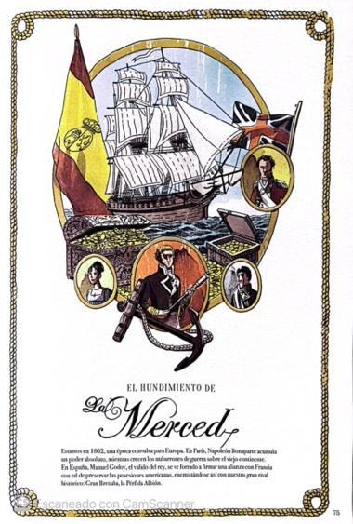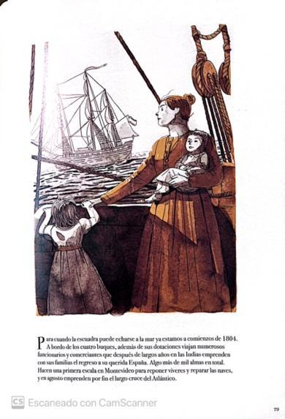
Source: El Tesoro del Cisne Negro (pages 75 y 79)

In contrast, in La Fortuna Amenábar allocates to this section an extensive sequence at the beginning of the second episode, twelve minutes in length. Technically complex, because it employs two ships for filming, its objective is to situate the entry into the story in an intense manner so that the human drama is perceived and, at the same time, to endow the event with importance within the context of the History of Spain. The representation of the past is key in the narrative because it functions as a narrative device that explains and legitimises the struggle of the protagonists. In this sense, recovering the ship is a metaphor: it means recovering the lost chapter of Spanish history.
Figures 7, 8, and 9: Battle between ships and explosion of La Mercedes
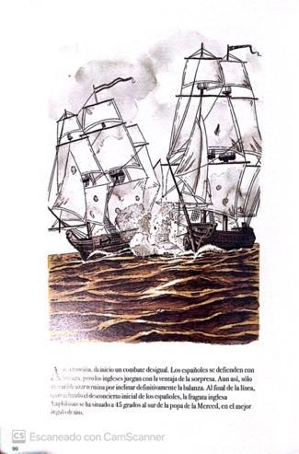
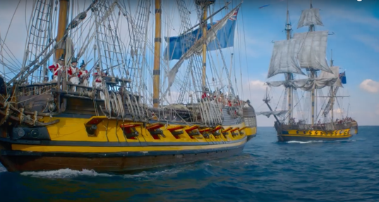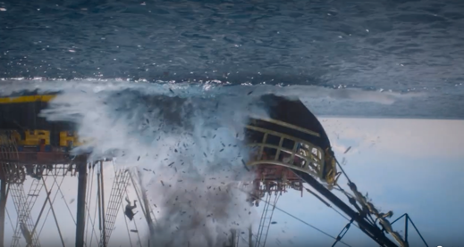
Source: El Tesoro del Cisne Negro (página 90) and screenshots from the series La Fortuna (Movistar+)

Formally, the adaptation respects the visual approach of the comic (see Figures 10, 11, 12, and 13). Amenábar takes as reference the adventure films of the 1980s and 1990s, and looks to Steven Spielberg as a directing model: “if I had any doubt about staging, I would say to myself: how would he [Spielberg] have resolved it?” (Yuste, 2021). For this reason, his discursive style relies on a functional, precise, and planned direction in terms of the choreography of the actors and the camera, but without displaying significant technical flourishes.
His most particular stylistic choice is used to differentiate the Anglo‑Saxon world from the Spanish one. The former is shown through a stabilised camera that moves on rails, whereas to depict the latter he uses a handheld camera in an attempt to portray the more disorderly and improvised atmosphere of the Spanish character, in addition to projecting differences in lighting. It is also worth noting that the series maintains a unified tonal result throughout its entire running time, distinguishing itself from the graphic novel, which, by contrast, articulates a narrative use of colour through a palette of yellows, greens, and blues that are prioritised according to the different countries where the story takes place.

Figures: 10, 11, 12, and 13: The encounter between the protagonists 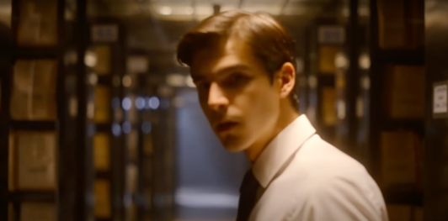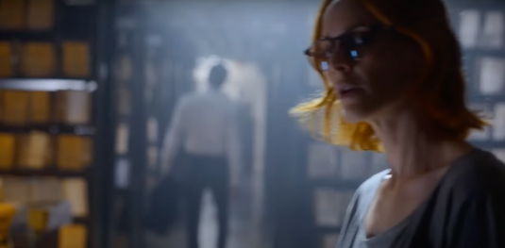
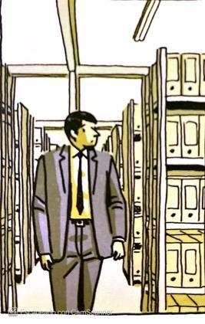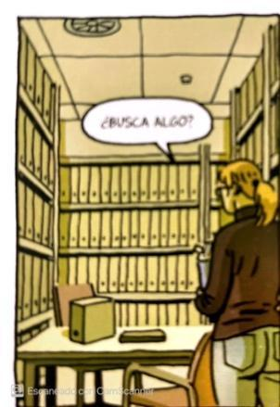
Source: El Tesoro del Cisne Negro (page 33) and screenshots from the series La Fortuna

Conclussions

After the analysis, it can be observed that the television adaptation of a graphic novel is something more than providing movement and sound to the drawings of the comic and injecting a concrete time frame into the telling of the story. It becomes evident that the transfer of fictional materials from the graphic medium to the television medium entails a transformation of the narrative of the original work. Both works propose, in general, a common story and coincide in their generic affiliation.

However, the adaptation presents structure variations, in the inclusion of new themes, in the dialogues, as well as in the characters, who appear portrayed with greater depth and more closely connected to the newly reformulated narrative lines of the television story. The stretching of sequences characterised by emotional intensity or dramatic weight is also noticeable. Although there is a formal intention to emulate the visual style of the source work, the stylistic differences produced as a consequence of the format change and the adoption of audiovisual language are also evident. These refer, for example, to editing, the use of the soundtrack, the handling of time, or the involvement of a live‑action artistic team, to cite the most obvious.

Despite these alterations, the television series faithfully adapts the story of the source text, without this being a positive or negative value. The quality of the audiovisual adaptation cannot be assessed by attending to its adherence to the signs, panels, and dialogues of the original work; on the contrary, it seems to be measured by the changes, whether small or large, that are introduced.

As noted, the main difference between the works lies in the greater narrative density of the audiovisual production given its production requirements and the time in which it is constituted. In this respect, it can be inferred that the television programme constitutes a larger, longer‑lasting container that allows for the incorporation of greater narrative development supported by instances such as characters or themes. It should be considered that the time devoted to viewing La Fortuna is potentially greater than the time required to read El tesoro del Cisne Negro and, consequently, textual addition exists. This dual property of the television series — long duration and block structure — makes it more flexible as a medium for adaptation.

Nevertheless, although this idea works in this specific case, it cannot and should not be generalised, since extending certain narrative aspects does not necessarily improve the quality of the text. By comparison, other cases function differently. For example, The Walking Dead develops a basic plot portion of the graphic novel and then expands and rearranges itself, multiplying through various settings and characters in multiple titles that refer to the source text, without guaranteeing quality in its result.

In any case, thanks to the narrative breadth permitted by the format of the television series, we know more about the characters; the events are more intertwined, and the settings appear more defined, even if the visual segments broadly correspond to the original representation in the graphic work.

The transformation from graphic text to audiovisual text thus entails a transfiguration resulting from the passage from one signifying structure to another. In this process, Amenábar, as indicated, skilfully transplants the semantic material without betraying the enunciative categories of the graphic novel, although this requires modifying certain narrative instances of the original text.

With regard to the relationship between the graphic novel and the audiovisual medium, it is concluded that both possess convergences in their expressive and narrative forms.

In La Fortuna, fiction appropriates the aesthetic and narrative elements of the graphic work and composes a different narrative, with a new structure that includes new themes, visual elements, sound, and narrative components that change the work, thus mediating between the graphic work and the audience. From the perspective of adaptation and transmediality studies, the passage from graphic novel to television series implies — in addition to narrative expansion — a visual reappropriation and a thematic reframing. That is, the resources of the television format are utilised to extend conflicts and politicise certain content. Therefore, we may speak of a new work, composed of additions, extensions, and transformations, which makes it autonomous in relation to the original text.

Thematically, the series articulates the tension between historical memory, heritage, and the global market. The conflict presented (recovering a shipwreck that may be the Spanish frigate Nuestra Señora de las Mercedes) allows the series to function, due to its scope, as a device for formulating national narratives in a serial and accessible key. That is, television fiction participates in the public construction of historical memory aimed at national audiences and, through its production approach, also international ones.

Regarding the discussion on the cultural and industrial implications of La Fortuna within the contemporary Spanish television context, Amenábar’s migration to television (directing and signing the script) reignites the longstanding debate on authorship in television, an environment otherwise dominated by collective production. That a film author signs a series is, in promotional and industrial terms, an act of authorial accreditation that concentrates aesthetic and branding expectations that function as a promotional resource and as an international attraction.

This approach aligns with Movistar+’s strategy of attributing promotional authorship to specific creators in order to build symbolic brand value in the television market. In any case, authorship in this instance becomes diluted, since Amenábar may contribute a recognisable imprint — aesthetic, rhythmic, generic references — but the series remains a product of creative teams that relativise the notion of the unique author.

La Fortuna is a symptomatic example of several structural phenomena in recent Spanish series production. It is a high‑budget production executed by VoD platforms (Movistar+), in international co‑production (in partnership with AMC Studios and distributed by Beta Films), with transnational talent (an ensemble cast including Spanish and Anglo‑American performers), and the adoption of modern production technologies and formats (virtual production, multi‑location filming). This industrial approach pursues two objectives: competing in the global “content war” with a work of high production value, and exporting a cultural product with a Spanish hallmark that also offers an appealing contribution to attract international audiences.

Bibliography

Aertsen, V. (2021). De la línea clara al movimiento perpetuo: realismo y dinamismo en la adaptación cinematográfica de Las aventuras de Tintín de Steven Spielberg. Trasvases entre la literatura y el cine, 2, 57-80. http://doi.org/10.24310/trasvasestlc.vi3.12153
Baetens, J, Frey, H. (2015). The graphic novel: an introduction. Cambridge University Press.
Balló, J. & Pérez, X. (2005). Yo ya he estado aquí: ficciones de la repetición. Anagrama.
Bourdieu, P. (2015). La distinción. Criterios y bases del buen gusto. Taurus.
Brembilla, P. y Pescatore, G. (2018). Adaptación, remediación, narrativa transmedia, ¿y qué más? El caso de los universos de Marvel y DC Cómics en el cine y la televisión. En A.N. García Martínez, M.J. Ortiz, (Eds.), Cine y series. La promiscuidad infinita. Salamanca: Comunicación Social. https://doi.org/10.52495/c2.emcs.1.c37
Canovaca, E. (2017). Aproximación a un modelo de análisis cultural de las adaptaciones de series televisivas. L’Atalante. Revista de estudios cinematográficos, 24, 71-83. https://revistaatalante.com/index.php/atalante/article/view/460/442
Cavanilles, J. (1 de noviembre de 2018). El Cisne Negro llega a las librerías, Castellón Plaza: https://castellonplaza.com/Paco-Roca-tesoro-cisne-negro
Ceberio, M. (23 de marzo de 2024). Paco Roca rompe los límites del cómic con las fosas comunes del franquismo. El País. https://elpais.com/babelia/2024-03-23/el-fenomeno-paco-roca-arrasa-con-la-memoria-historica.html?sma=babelia_2024.03.23
Cascajosa, C. (2016). La cultura de las series. Laertes.
El Refaie, E. (2015). Autobiographical Comics: life writing in pictures. University Press of Mississippi.
Engert, V., Revelli, M., & Lisa, F. (2023). Sobre escrituras académicas divergentes. Literatura y transposición audiovisual. Ñawi: arte, diseño y comunicación, 7(2), 69-79. https://doi.org/10.37785/nw.v7n2.a4
Flantrmsky-Cárdenas, O. G. (2022). Cómic y novela gráfica como literatura menor: debates y validez como producto cultural. Folios, 56, 1-16. https://doi.org/10.17227/folios.56-13477
Garín, M. (2017). Heridas infinitas: estructura narrativa y dinámicas seriales en la ficción televisiva. L’Atalante. Revista de estudios cinematográficos, 24, 27-41. https://revistaatalante.com/index.php/atalante/article/view/414/437
Gil, A., & Pardo, P.J. (2018). Intermedialidad. Modelo para armar. En A. J. Gil y P. J. Pardo (Eds.), Adaptación 2.0. Estudios comparados sobre intermedialidad (pp. 11-38). Orbis Tertius.
Gutiérrez, F. (2010). El cómic “Persépolis” y su reescritura fílmica. En J. A. Pérez Bowie, (Coord.), Reescrituras fílmicas: nuevos territorios de la adaptación (pp. 241-255). Ediciones Universidad de Salamanca.
Hutcheon, L. (2006). A Theory of Adaptation. Routledge.
Jenkins, H. (2011). Transmedia 2.0: reflexiones adicionales. https://henryjenkins.org/blog/2014/09/transmedia-202-reflexiones-adicionales.html
López, A. (2020). El Lucifer de Neil Gaiman como caso límite de los estudios de adaptación. Cuadernos del centro de Estudios de Diseño y Comunicación, 123, 87-101. https://doi.org/10.186882/CDC.VI123.4407
López, F.J. (2012). Modificaciones narrativas en la adaptación cinematográfica del cómic japonés. Revista Comunicación, 10, 1, 1549-1564. https://revistascientificas.us.es/index.php/Comunicacion/%20article/view/21778
Mateos-Pérez, J. (2023). La narrativa en la ficción televisiva española. Panorámica, particularidades del objeto, metodología de análisis y focos de atención. En C. Cascajosa y J. Mateos-Pérez (Eds.). Análisis de la ficción televisiva española. Propuestas, metodologías y enfoques de investigación, (pp. 135-145). Síntesis.
Maule, R. (2007). Cultural Specificity and TransnationalAddress in the New Generation of Spanish Film Authors: The Case of Alejandro Amenábar. C. Sánchez-Conejero (Ed.), Spanishness in the Spanish Novel and Cinema of the 20th-21st Century, (pp. 107-120). Cambridge Scholars Publishing.
McCloud, S. (1994). Understanding Comics. The invisible Art. Harper Perennial.
Moran, A., & Malbon, J. (2007). Understanding the global TV format. Intellect Books.
Nuestra Señora de las Mercedes (2024). [Exposición permanente]. Museo Nacional de Arqueología Subacuática ARQVA. Cartagena, España. Ministerio de Cultura.
Peña, V. (2007). Transtextualidad y relato audiovisual. Comunicación, 5, 131-147. https://idus.us.es/items/ad80422f-9b11-4366-b356-cbf9a162ec1f
Pereira, X. (2018). Memoria paria y reterritorialización gráfica en Los surcos del azar de Paco Roca, Transitions: Journal of Franco-Iberian Studies, 12, 57-85. https://www.researchgate.net/publication/336742765_Memoria_paria_y_reterritorializacion_grafica_en_Los_surcos_del_azar_de_Paco_Roca
Pérez Bowie, J.A. (2010). Reescrituras fílmicas: nuevos territorios de la adaptación. Ediciones Universidad de Salamanca.
Raya, I. (2017). Adaptando el terror cinematográfico a la serialidad televisiva. El caso de Scream. Fotocinema: revista científica de cine y fotografía, 14, 183-204. https://doi.org/10.24310/Fotocinema.2017.v0i14.3598
Rivero, C. (2019). Abre los ojos: ¿Actualización o reescritura de La vida es sueño? Hesperia. Anuario de filología hispánica, 22(1), 77-91. https://revistas.uvigo.es/index.php/AFH/article/view/1453
Scolari, (2013). Narrativas transmedia. Cuando todos los medios cuentan. Deusto-Planeta.
Serceau, M. (1999). L’adaptation cinématographique des textes littéraires. Théories et lectures. Éditions du Céfal.
Soto, G. (2023). La era del consumo en la esfera audiovisual: series y plataformas streaming. SERIARTE, 3, 103-123.
Stake, R. E. (1998). Investigación con estudio de casos. Ediciones Morata.
Terrasa, R. (2018, 21 de noviembre). El tesoro del Cisne negro: cuando España recuperó la mayor fortuna jamás encontrada bajo el mar. El Mundo. https://www.elmundo.es/papel/cultura/2018/11/21/5bf43d38e5fdeab23f8b463c.html
Verevis, C. (2006). Film Remakes. Edinburgh University Press.
Yin, R. K. (2018). Investigación sobre studio de casos: diseño y métodos. Ediciones Morata.
Yuste, J. (2021, 30 de septiembre). Alejandro Amenábar: en ‘La Fortuna’ me preguntaba: ¿cómo lo habría hecho Spielberg? El Español. https://www.elespanol.com/el-cultural/cine/series/20210930/alejandro-amenabar-fortuna-preguntaba-hecho-spielberg/615940224_0.html

Funding

This work forms part of the research project “Spanish Television Series of the 21st Century: Narratives, Aesthetics, Historical and Social Representations”, funded by the Research Talent Attraction Programme of the Community of Madrid. Ref. 2023‑5A/SOC‑28930.


Creative Commons Licence
Miguel Hernández Communication Journal mhjournal.org

Academy Award and Golden Globe for Best Non‑English Language Film; eight Goya Awards (Best Director, Best Screenplay); Jury Prize at the Venice Film Festival; BAFTA Award for Best Original Screenplay, among others..
This theme also connects with the work recently published by Paco Roca —together with Rodrigo Terrasa— El abismo del olvido, which precisely rescues a case from the Francoist mass graves to present a work on the protection of memory and the need to provide relatives with a dignified burial.
Fear The Walking Dead (2015-nowadays); The Walking Dead: World Beyond (2020); Tales of The Walking Dead (2022); The Walkind Dead: Dead City (2023); The Walking Dead: Daryl Dixon; The Walking Dead: The Ones Who Lives (2023).

